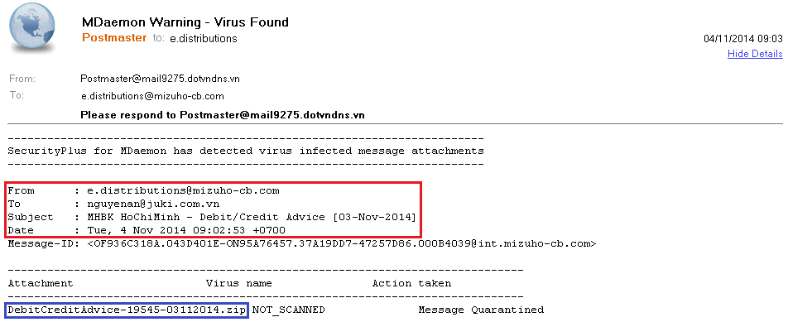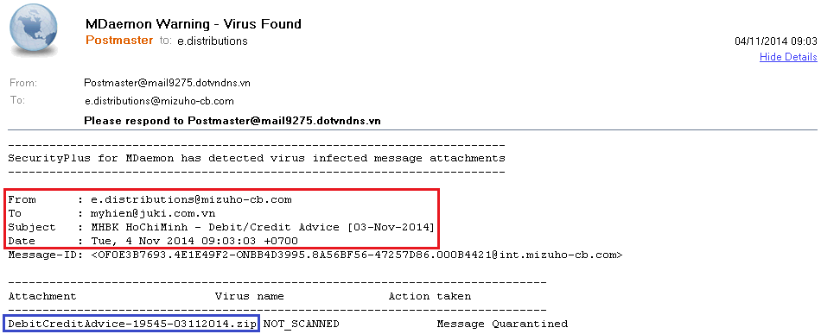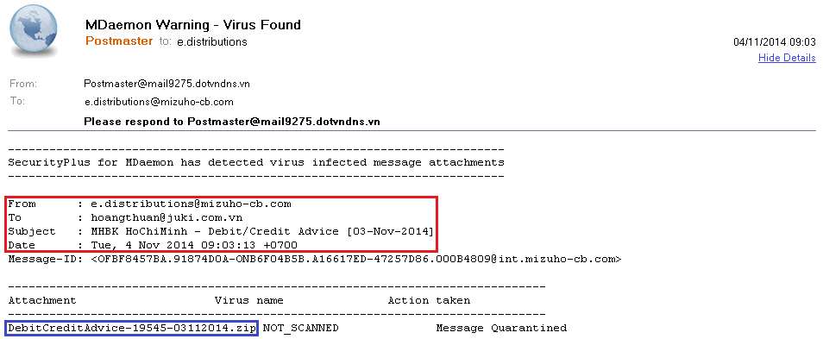
No virus found in this message.
Checked by AVG - www.avg.com
Version: 2015.0.5557 / Virus Database: 4189/8513 - Release Date: 11/05/14

